How to write Test Cases

- Test case template

Test case ID – name

Description: short description
Requirements: UC x.y flow z |  |  |  | Business Pri.
 |  |  |  | Low/Medium/High
Setup: short statement
Pre-conditions: detailed system status required at test entry
Seq. | Steps |  | Expected results | Notes / Status
Basic flow: short name
 | (…with actual test data )
Alternative flow 1: short name
Alternative flow 2: short name
Alternative flow n: short name
Post conditions: |  |  | System status at basic flow exit
References: |  |  | Other test cases referenced in the specified flows
Defect report (only for Acceptance test)

Step |  | (…where the test failed )
Inputs |  | (…actual test data used )
Outputs |  | (…what happened )
Test result (OK/FAILED): |  | (FAILED if the test did not pass )

- How to write a Test Case

We will describe a 4-step process for generating test cases from a fully detailed use case:
1. For each use case, generate a full set of use-case scenarios.
2. For each scenario, identify at least one test case
3. For each test case, identify the conditions that will make it "execute."
4. For each test case, identify the data values with which to test.

Step 1: Identify the Use-Case Scenarios
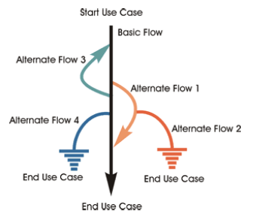
Fig- Flow of events of a Use Case
In Table 1 we've identified eight possible scenarios for the sample use case. Note that the use case we've described is not an overly complex one, and yet a significant number of scenarios may result. As the use cases grow more complex, more and more scenarios will result. In many situations, you will need to devise a testing strategy that recognizes that it is impractical to test all possible scenarios but still assures that adequate testing is achieved.

Table 1. Scenario Matrix
Scenario Number | Originating Flow | Alternate Flow | Next Alternate | Next Alternate
1 | Basic flow
2 | Basic flow | Alternate flow 1
3 | Basic flow | Alternate flow 1 | Alternate flow 2
4 | Basic flow | Alternate flow 3
5 | Basic flow | Alternate flow 3 | Alternate flow 1
6 | Basic flow | Alternate flow 3 | Alternate flow 1 | Alternate flow 2
7 | Basic flow | Alternate flow 4
8 | Basic flow | Alternate flow 3 | Alternate flow 4
In addition, you should be aware that not all scenarios may be described in the original use case and that this scenario discovery process may well need to be conducted interactively with the development team. There are two reasons for this.
- The use cases developed for implementation are not 100 percent exhaustive and are written at a level of detail that may be insufficient for testing.
- The test team's review process will create new discoveries and additional scenarios that may result from executing the use case.

Step 2: Identify the Test Cases
The test case should contain the parameters of the test to be conducted, including the conditions of the test and the expected results. One common format, used only to learn how to design test cases, illustrated in Table 2, is to use a matrix in which each row represents a specific test case and the columns represent scenarios, conditions, data values, and expected and actual results.

Table 2. Matrix for Testing Specific Scenarios
Test Case ID | Scenario/ Condition | Data Value 1 | Data Value 2 | Data Value N | Expected Result | Actual Result
1 | Scenario 1
2 | Scenario 2
3 | Scenario 2
Note in Table 2 that more than one test case can result from a specific scenario (see test case IDs 2 and 3, both for scenario 2). Typically, this arises because of various logical constructs identified in a single step in a use case. For example, consider the following step in a use case:
The homeowner enters the desired lighting sequence for each day of the week up to a maximum of seven different daily settings. The system confirms acceptance of each daily entry with a beep.
This single step in the use case will produce two test cases from this step (Table 3).

Table 3. Two Test Cases for One Scenario
Test Case ID | Scenario/ Condition | Description | Expected Result
1 | Scenario 6 | Less than seven sequences entered | Sequence saved  System beeps
2 | Scenario 6 | Attempt to enter an eighth sequence | Error?

Step 3: Identify the Test Conditions
The next step is to identify the specific conditions in the test case that would cause it to execute. In other words, what conditions cause a user to execute a specific event or sequence of events within a use case? During this process, the tester searches the use-case steps for the various data conditions, branches, and so on that would cause a specific test case to occur. For each such condition identified, the tester enters a new column in the matrix, representing the specific condition identified. In this initial pass, it is adequate to simply identify that a condition exists, create the column entry, and then indicate which of the three states that could occur for that condition (valid, invalid, or not applicable) is appropriate.
- Valid (V) indicates a condition that must be true for the basic flow to execute.
- Invalid (I) indicates a condition that will invoke the alternate flow, causing a specific scenario to occur.
- Not applicable (N/A) indicates that an identified condition is not applicable to that specific test case ID.

Step 4: Add Data Values to Complete the Test Case
We've made good progress. We have now identified all the conditions that need to be tested to test a specific use case fully. We're not quite done, however—without real data, test cases are merely descriptions of conditions, scenarios, and paths without concrete values to identify them succinctly. Without such data, it's not possible to execute the test case and determine the results. In many cases, the use cases themselves will not directly identify these data values, and you will have to look to supplementary specifications to find performance specs, valid data ranges for input forms and interface protocols, and so on. However, this is not a new problem to the tester; just use your normal techniques for finding the data ranges.
This is also the time to make sure that test cases address any special requirements defined for the use case. These include such things as minimum / maximum performance, sometimes combined with minimum / maximum loads, or data volumes expected during the execution of the use cases.
Once you have identified the data ranges, you can finalize the test matrix with those values. Then you are ready to execute the test cases.
- How to write a Test Case – Example

The Use Case (fragment):
………………
Business Rules:
- A variable definition must have a valid syntax
- A variable must have at least one type set (Online / Offline)
- A variable can have more types set (Online and Offline)
…………..

Manage Calculated Variables

Functionality
Basic flow: Update Variable
- User selects “Responses management > Manage Calculated Variables” menu item.
- The ‘Manage calculated variables’ page is first displayed.
- This page has the following fields:
  - Variable name
  - Variable description
  - Variable selection list
  - Variable definition area
- The user fills in Variable name and / or description; the user can use “Browse variables” button to browse variables (see fig.5.17.1)
- The user clicks “Filter” button
- The system loads and displays the selected calculated variables records
- The user selects a record by clicking “Selected” checkbox
- The user clicks “Load Variable” button
- The system loads the Variable definition into the Variable definition list
- The user modifies the desired Variable definition (using also “Select variables“ button)
- The user clicks “Save Variable” button
- The system saves the updated Variable

Alternative flow 1: Add Variable
- User selects “Responses management > Manage Calculated Variables” menu item.
- The ‘Manage calculated variables’ page is first displayed.
- The user clicks “New Variable” button.
- The user fills in Variable name and description
- The user fills in the desired Variable definition (using also “Select variables“ button)
- The user clicks “Save Variable” button
  - If the variable name is already used by another variable, an error message (see fig 5.27) is displayed
  - The user changes the variable name
  - User clicks “Save” button and the step a) is executed again
- The system saves the new Variable

Alternative flow 2: Delete Variable
- User selects “Responses management > Manage Calculated Variables” menu item.
- The ‘Manage calculated variables’ page is first displayed.
- The user fills in Variable name and / or description
- The user clicks “Filter” button
- The system loads and displays the selected calculated variables records
- The user selects a record by clicking “Selected” checkbox
- The user clicks “Load Variable” button
- The system loads the Variable definition
- The user clicks “Delete Variable” button
- The system displays the message “Are you sure you want to delete the [name] variable?”
- If the user clicks “Yes” button, the system deletes the Variable
- Else, the variable is not deleted

Alternative flow 3: Select variables
- User selects “Responses management > Manage Calculated Variables” menu item.
- The ‘Manage calculated variables’ page is first displayed.
- The user (using the “update” or “add” flow, has loaded a variable definition into the “Variable definition data” multi line input box)
- User clicks “Select variables” button.
- The system displays the “Select variables” dialog.
- The user can choose a (calculated) variable or an operand; “find” feature is provided to search the desired item given the item name (or prefix)
- The system inserts the selected item in the variable definition multi line input box “Variable definition data”, at the current input pointer

Screenshots

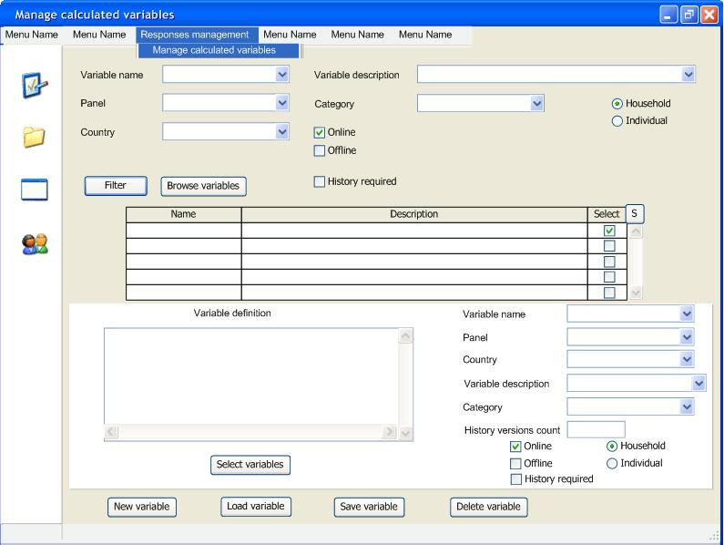
Figure 5.16 Manage calculated Variables

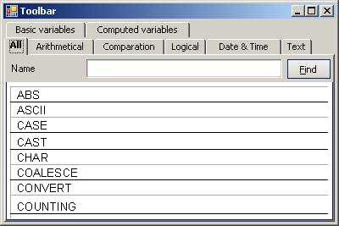
Figure 5.17 Select variables

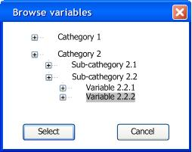
Figure 5.17.1 Browse variables

Let’s write the test case for the Update flow:

- User selects “Responses management > Manage Calculated Variables” menu item.
- The ‘Manage calculated variables’ page is first displayed.
- This page has the following fields:
  - Variable name
  - Variable description
  - Variable selection list
  - Variable definition area
- The user fills in Variable name and / or description; the user can use “Browse variables” button to browse variables (see fig.5.17.1)
- The user clicks “Filter” button
- The system loads and displays the selected calculated variables records
- The user selects a record by clicking “Selected” checkbox
- The user clicks “Load Variable” button
- The system loads the Variable definition into the Variable definition list
- The user modifies the desired Variable definition (using also “Select variables“ button)
- The user clicks “Save Variable” button
- The system saves the updated Variable
Step 1: Identify the scenarios

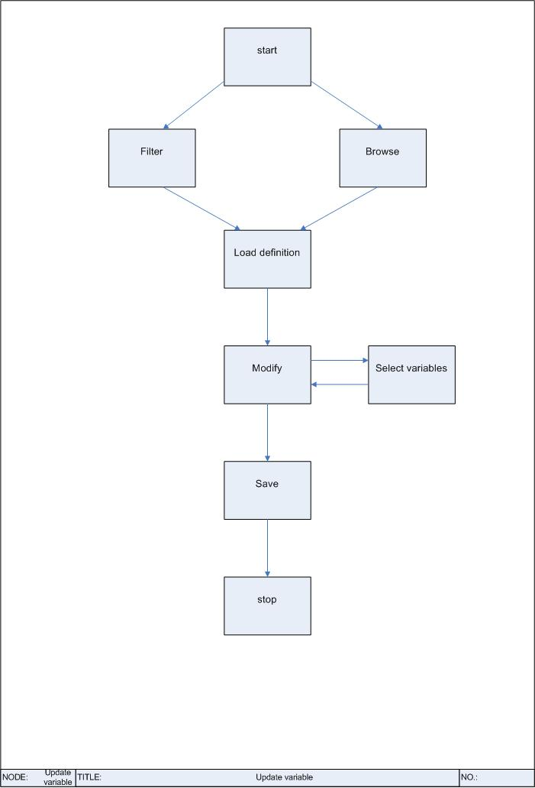

Scenarios:
1 | start | filter | load | modify | save | stop
2 | start | browse | load | modify | save | stop
3 | start | filter | load | modify | select variables | save | stop
4 | start | browse | load | modify | select variables | save | stop
Step 2: Identify the test cases

Nr. | Step | Step | Step | Step | Step | Step | Step | Result
1 | start | Filter | load | modify | save | check save |  | OK
2 | start | Filter | load | modify | save | error msg. |  | ERR
3 | start | browse | load | modify | save | check save |  | OK
4 | start | browse | load | modify | save | error msg. |  | ERR
5 | start | Filter | load | modify | select variables | save | check save | OK
6 | start | Filter | load | modify | select variables | save | error msg. | ERR
7 | start | browse | load | modify | select variables | save | check save | OK
8 | start | browse | load | modify | select variables | save | error msg. | ERR

Step 3: Identify the test conditions

Let’s detail only the ‘modify’ step: (V = field filled, I = field empty)
Nr. | Name | Description | Definition | Panel | Country | Category | Hist.vers | Online | Offline | Result
1 | V | V | V | V | V | V | V | N/A | N/A | OK
2 | I | V | V | V | V | V | V | N/A | N/A | ERR
3 | V | I | V | V | V | V | V | N/A | N/A | ERR
4 | V | V | I | V | V | V | V | N/A | N/A | ERR
5 | V | V | V | I | V | V | V | N/A | N/A | ERR
6 | V | V | V | V | I | V | V | N/A | N/A | ERR
7 | V | V | V | V | V | I | V | N/A | N/A | ERR
8 | V | V | V | V | V | V | I | N/A | N/A | ERR

Step 4: Add test values

Now, let’s see the details for case 1:

Nr | Name | Description | Definition | Panel | Country | Category | Hist.vers | Hist.req | Online | Offline | House/Indiv | Result
1 | ‘V1’ | ‘V1descr’ | valid | ‘P1’ | ‘USA’ | ‘C1’ | 4 | ON | ON | OFF | House | OK
2 | ‘V1’ | ‘V1descr’ | valid | ‘P1’ | ‘USA’ | ‘C1’ | 0 | ON | ON | OFF | House | ERR
3 | ‘V1’ | ‘V1descr’ | valid | ‘P1’ | ‘USA’ | ‘C1’ | 0 | OFF | OFF | ON | Indiv | OK

Surprise! We missed this…we expect here an error message saying that if I choose to have history versioning, the versions limit must be a positive integer. Done? …not yet!

How about the following case: (we expect an error message saying that we must choose at least one of Online, Offline)

Nr | Name | Description | Definition | Panel | Country | Category | Hist.vers | Hist.req | Online | Offline | House/Indiv | Result
4 | ‘V1’ | ‘V1descr’ | valid | ‘P1’ | ‘USA’ | ‘C1’ | 4 | ON | OFF | OFF | Indiv | ERR

Done? …not yet! How about an invalid Definition?

Nr | Name | Description | Definition | Panel | Country | Category | Hist.vers | Hist.req | Online | Offline | House/Indiv | Result
5 | ‘V1’ | ‘V1descr’ | invalid | ‘P1’ | ‘USA’ | ‘C1’ | 4 | ON | ON | OFF | Indiv | ERR

And, finally: (we expect here 3 error messages…)

Nr | Name | Description | Definition | Panel | Country | Category | Hist.vers | Hist.req | Online | Offline | House/Indiv | Result
5 | ‘V1’ | ‘V1descr’ | invalid | ‘P1’ | ‘USA’ | ‘C1’ | 0 | OFF | OFF | OFF | Indiv | ERR

